BEIRNE B. CARTER CENTER
FOR IMMUNOLOGY RESEARCH
Fall 2022 CIC SEMINAR SERIES

Craig L. Slingluff Jr., M.D.
Joseph Helms Farrow Professor of Surgery
University of Virginia
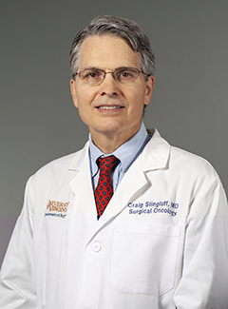

"Optimizing cancer vaccine adjuvants
and enhancing T cell homing to tumor”
Melssen MM, Petroni GR, Grosh WW, Varhegyi N, Chianese-Bullock KA, Smolkin ME, Smith KT, Galeassi NV, Deacon DH, Gaughan EM, Slingluff CL Jr. A Multipeptide Vaccine Plus Toll-like Receptor (TLR) Agonists LPS or polyICLC in Combination with Incomplete Freund's Adjuvant (IFA) in Melanoma Patients. Journal for ImmunoTherapy of Cancer, 2019 Jun 27;7(1):163. doi: 10.1186/s40425-019-0625-x. PMID: 31248461. https://rdcu.be/bH0eC

Meneveau MO, Kumar P, Lynch KT, Patel SP, Slingluff CL Jr. The vaccine-site microenvironment: impacts of antigen, adjuvant, and same-site vaccination on antigen presentation and immune signaling. J Immunother Cancer. 2022 Mar;10(3):e003533. doi: 10.1136/jitc-2021-003533. PMID: 35277457

Monday, September 19, 2022
3:00 PM (please note time & in person location Pinn 1005)
Host: Dr. Timothy Bullock
***PLEASE DISTRIBUTE***

